Pythium-not a true fungus, but instead a ‘water-mold’, similar to Phytophthora

Life Cycle:
- Oospore germinates and forms a germ tube OR can produce a sporangium
  - Sporangia produce zoospores which can create a cyst before germinating and forming germ tube
- Germ tubes grow into mycelium which will invade the plant
- Hyphae will form appresoria to penetrate into plant host
- Mycelium will invade plant root cells and vascular tissue
- Roots will turn brown and mushy and often slimy
  - Outer root epidermis may slough off exposing pith and vascular bundle
- Above ground plant parts will wilt and die due to water translocation being shut off
  - Leaves wilt quickly and eventually become necrotic and die
- Mycelium in soil can fuse with compatible mating type and then form sporangia which produce motile zoospores
- Motile zoospores or growing mycelia can then infect new plant roots

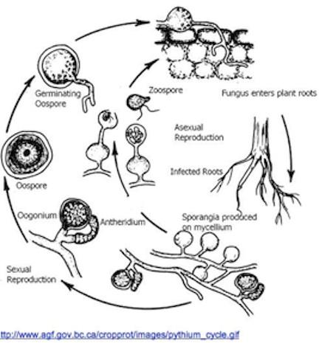
Simple Pythium disease diagram

Table 14.1 Similarities and differences between true fungi and water molds.
 | Fungi | Water molds (Oomycete)
Hierarchical Kingdom | Fungi | Chromalveolata
Mode of reproduction | Spore | Motile zoospores
Method of dispersal | Wind, water, animal | Mainly water and mechanical damage
Vegetative growth structure | Mycelium or yeast | clear, bubbly filaments without septa
Nuclear state of vegetative body | N+N dikaryotic or haploid | Diploid 2N
Cell wall constituents | Chitin, b-glucans | Cellulose, b-glucans, hydroxyproline
Reproductive structure | Sporocarp or conidiophore | Antheridium fuse with oogonia to form oospore, sporangiophore

Oomycota
Water molds share some superficial similarities with fungi, including the filamentous growth and presence of cell walls (Table 1). The materials that comprise the cell wall among Oomycetes are cellulose and beta-glucans, rather than chitin as in fungi. Also, water mold spores (zoospores) have two flagella to help them move and navigate through liquid substrates. The only true fungi that possess flagella are the chytrid zoospores that have a singular posterior flagellum.
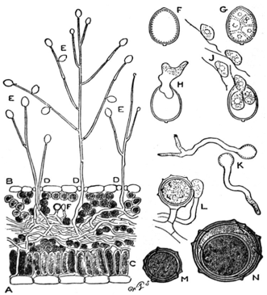
Figure 14.1. A) Leaf cross-section of Phytophthora infestans hyphae growing through leaf tissue, B) P. infestans sporophores sprouting through stomata. C) Palisade mesophyll layer of leaf D) Under (abaxial) side of leaf E) Sporangia hold zoospores F,G,H) Sporangium development J) Mobile zoospores K) Germinating zoospores L) Antheridium and Oogonium fusion M,N) Development of oospore (wikisource).
Oomycetes like Pythium have a complex lifecycle with different forms and growth patterns. Water mold’s life begins, like a fungus, with a spore. This spore begins to grow when it lands on a suitable growth substrate, such as plant tissue. The spore will germinate and begin to grow hyphae. Like fungi, they access host tissue by developing an appressorium, releasing extracellular enzymes to assist in damaging and entering host tissue. Hyphae invade host tissue and siphon nutrients to the oomycete (Fig. 1).
Water molds are typically transmitted in water and have even been found in some irrigation waters (Ali-Shtayeh et al. 1991). Therefore eliminating any stagnant or still water in or near fields may help reduce harboring pathogens in close proximity to crops. Once a field is infected, zoospores of the fungus are able to encyst in a dormant state. When the environment becomes favorable again, the cyst can germinate and infect plants. This is why once soil has been contaminated with these organisms, it can be difficult to remediate.
A distinguishing factor between water molds and fungi are that water molds have mobile asexual zoospores that can actively disperse in water. Therefore damp, water-logged soils with little oxygen presence create the optimal environment for these pathogens to grow and flourish, especially if a susceptible host is planted nearby.

